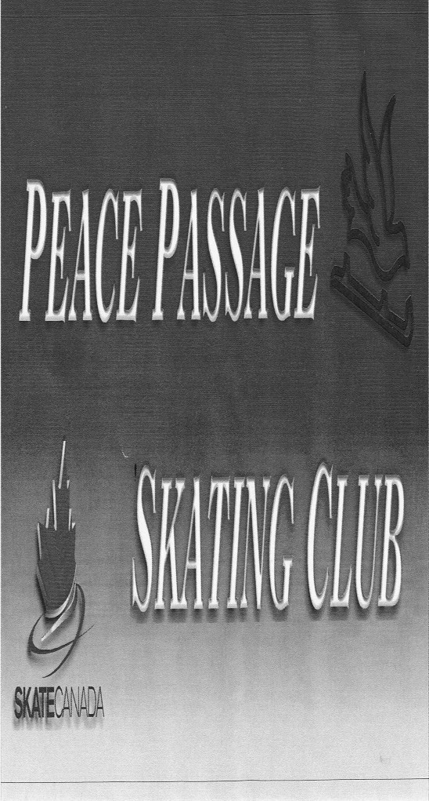
www.peacepassage.ca January 2017
Welcome back from what I hope was a relaxing fun filled holiday with friends and family. All of the skaters have been working so hard up to this point, and I can’t wait to keep up the pace going into the New Year.
- Coach Amanda

Dates to Remember!!
January 4^{th -} Skating resumes all Programs
January 11th - Pajama Day all programs
January 15th – Simulation Day
January 20nd-22th – Regionals competition Williams Lake
January 27th-29st – Grande Prairie Competition
February 6th – General Membership meeting
February 8th -Valentines Fun Day
February 13th – BC Family Day no Skating
February 17th-19th – Totem Competition in Dawson Creek
February 24th – 26th – Test Day in Fort St John
March 3rd -5th – Super Series Star Skate Final in Kelowna
March 8th – Last day of CanSkate
March 10th – Ice Show Dress Rehearsal
March 11th – Awards Banquette
March 12th – Ice Show
-Raffle Draw

2016/2017 Executive:
President: Sandra Bueckert
Vice President: Lisa Johnson
Treasurer: Teri Borsa
Secretary: Bethany Comer
Membership/Block Chair: Marla Demoulin
Fundraising Chair: Sandra Carmichael
Bingo/Gaming Chair: Todd Koponyas
Test/Competition Chair: Niki McAvany
Publicity Chair: Amanda Thomas
Ice Show Chair: Stephanie Pajor
Social Convener: Tammy Koponyas
Club Clerk Amanda Thomas

Pajama day
January 11th we will be having a pajama day at skating. Come in your favourite PJ’s for a fun day of skating and snac
ks

Fundraising
After our meeting in December we have decided to waive the prepayment for the raffle tickets and are going back to handing money in with the sold book. The Raffle Tickets are still being handed out please see Sandra Carmichael to pick your Raffle books. Reminder that every skater is required to sell 1 book each, any books sold after are worth 1 block.
We have lots of Save on More Gift Cards available see Sandra Carmichael to get your order.
We are recycling for blocks! If you have bottles or cans for recycling you can return them to the Fort St John Bottle Depot and deposit the money into an account that has been set up there. Just tell them its for Peace Passage Skating account # 215 and remember to bring the receipt to Sandra Carmichael. Every $100 recycled is 1 block of fundraising!

PLEASE CHECK BLACK BOARD FOR ANY CHANGES OR NEWS THAT MAY COME UP
January 2017
Sunday | Monday | Tuesday | Wednesday | Thursday | Friday | Saturday
1 | 2 | 3 | 4  Fist day of Skating all programs | 5 | 6 | 7
8  No Ice (Hockey) | 9  Executive meeting | 10 | 11  PJ Day all programs | 12 | 13 | 14
15  Simulation | 16 | 17 | 18 | 19 | 20  No Skating (hockey)  Regionals comp-Williams Lake | 21  Regionals comp- Williams Lake
22  No Skating (hockey)  Regionals comp-Williams Lake | 23 | 24 | 25 | 26 | 27  Peace Region Invitational-GP | 28  Peace Region Invitational-GP
29  Peace Region Invitational-GP | 30 | 31

Skating Schedule

Monday Wednesday Friday
CanSkate AM 10:15 – 11 CanSkate AM 10:15 – 11 Group C 4 – 5:30
CanSkate Pm 4:15 – 5 CanSkate Pm 4:15 – 5 Group B 5:30 – 6:30
Group A 5 – 6 Group A 5 - 6
Group B 6 – 7 OFF ICE GROUP B & C 5 - 6 Sunday
Flood 7- 7:15 Group B 6:15 – 7:15 Group A 2 – 2:45
Group C 7:15 – 8:30 Group C 7:15 – 8:30 Group B 2:45 – 3:45
Group C 3:45 – 4:45

