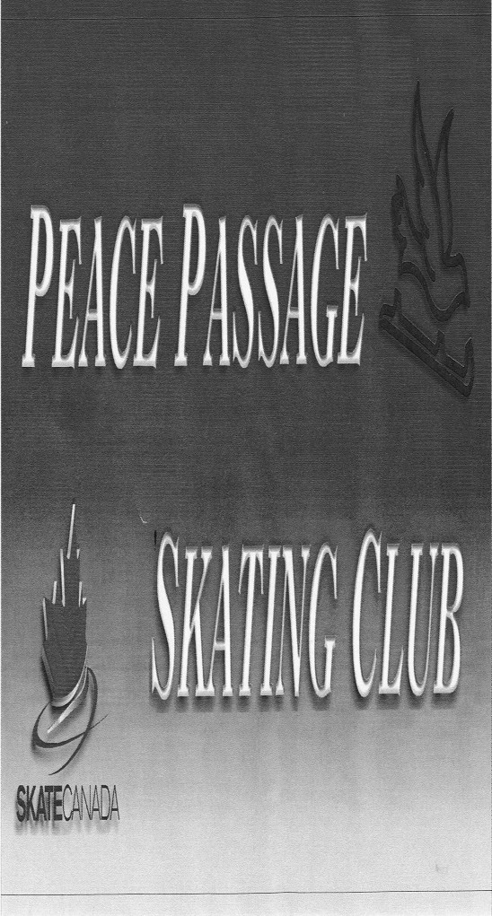
www.peacepassage.ca February 2017
2016/2017 Executive:
MARK YOUR CALENDARS!!
February 15th – General Membership meeting
February 8th -Valentines Fun Day
February 13th – BC Family Day no Skating
February 17th-19th – Totem Competition in Dawson Creek
February 24th – 26th – Test Day in Fort St John
March 3rd -5th – Super Series Star Skate Final in Kelowna
March 8th – Last day of CanSkate
March 10th – Ice Show Dress Rehearsal
March 11th – Awards Banquette
March 12th – Ice Show
-Raffle Draw

President: Sandra Bueckert
Vice President: Lisa Johnson
Treasurer: Teri Borsa
Secretary: Bethany Comer
Membership/Block Chair: Marla Demoulin
Fundraising Chair: Sandra Carmichael
Bingo/Gaming Chair: Todd Koponyas
Test/Competition Chair: Niki McAvany
Publicity Chair: Amanda Thomas
Ice Show Chair: Stephanie Pajor
Social Convener: Tammy Koponyas
Club Clerk Amanda Thomas

Fundraising
Please remember to pick up your raffle tickets from Sandra Carmichael every skater is required to sell 1 book each, any books sold after are worth 1 block. The raffle is a 50/50 draw so the more tickets sold the greater the prize, as of Feb 6th the take home prize is aprox. $2050
We have lots of Save on More Gift Cards available see Sandra Carmichael to get your order.
We are recycling for blocks! If you have bottles or cans for recycling you can return them to the Fort St John Bottle Depot and deposit the money into an account that has been set up there. Just tell them its for Peace Passage Skating account # 215 and remember to bring the receipt to Sandra Carmichael. Every $100 recycled is 1 block of fundraising!

Fun Day
February 8th we will be having our Valentines Fun Day.

Competitions/Test Days
The Grande Prairie Regional Invitational Competition held January 27th – 29th was a huge success for our girls. Results: Alexi Bueckert 3rd – STAR 5 Solo & 4th – Bronze Interpretive, Kyla McAvany Bronze ribbon – STAR 3 solo & Silver ribbon – Intro Interpretive, Lane McAvany Bronze ribbon – STAR 3 Solo, and Halla Aitken 1st - Gold Interpretive.

Upcoming Competitions:
- Totem Interclub in Dawson Creek Feb 17th – 19th.
- STARSkate Final in Kelowna Mar. 3rd – 5th.
Upcoming Test Days:
- Fort St John Feb 24th – 26th
PLEASE CHECK BLACK BOARD FOR ANY CHANGES OR NEWS THAT MAY COME UP
February 2017
Sunday | Monday | Tuesday | Wednesday | Thursday | Friday | Saturday
 |  |  | 1 | 2 | 3 | 4
5 | 6 | 7 | 8 | 9 | 10 | 11
12 | 13  No Skating | 14 | 15  General membership meeting @ 5pm | 16 | 17  Totem competition  DC  No Skating | 18  Totem competition  DC  No Skating
19  Totem competition  DC  No Skating | 20 | 21 | 22 | 23 | 24  Test Day  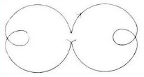  FSJ | 25  Test Day  FSJ
26  Test Day  FSJ | 27 | 28

Skating Schedule
Monday Wednesday Friday
CanSkate Pm 4:15 – 5 CanSkate Pm 4:15 – 5 Group C 4 - 5:30
Group A 5 – 6 Group A 5 – 6 Group B 5:30 - 6:30
Group B 6 – 7 OFF ICE GROUP B & C 5 - 6 Sunday
Flood 7- 7:15 Group B 6:15 – 7:15 Group A 2:30 – 3:15
Group C 7:15 – 8:30 Group C 7:15 – 8:30 Group B 3:15 – 3:45
Group C 3:45 – 5:00
Special O 5:00 – 5:30

